OS Design: The interrupt handling system

Jeroen van Bemmel (jbemmel@zonnet.nl), 15/1/2005

Introduction
The part of the OS that deals with hardware interrupt handling is important, as it determines some of the real-time characteristics of the system. This document provides details on a software design and caveats of the interrupt handling subsystem for the Intel i386 architecture.
This document is intended for students, OS developers and anyone else with an interest in operating system internals. Some general knowledge about the i386 architecture is recommended. This document does not cover: software interrupts or other parts of the X86 CPU architecture, or interrupt handling in an SMP environment (which is even more complex).

Background
Hardware interrupts occur asynchronously with respect to regular instruction execution by the CPU. The occurrence is in principle unpredictable, although under normal circumstances one may assume an upper limit for the number of interrupts a device will generate, and some devices generate interrupts regularly. An interrupt is generally an indication that something of importance to the system has occurred, which requires immediate attention. Handling an interrupt typically means reading some data from a device, setting up the appropriate structures for further processing, signaling successful reception to the device and returning to whatever task the CPU was executing.
On the i386 an interrupt causes the current instruction pointer (EIP), flags (EFLAGS) and current code segment (CS) to be saved on the stack ([ESP]) of the current process / thread. In total these are 12 bytes of information added on top of the stack, and more may be added during execution of the handler. This may not seem that much, but the stack size is limited and a large number of consecutive interrupts will cause an overflow unless preventive measures are taken.
The i386 supports up to 15 IRQ lines, some of which may even be shared to connect multiple devices. There is a configurable order of priority for dealing with simultaneous interrupts on different lines, ranging from strict to rotating priorities. Historically several types of devices have their own fixed IRQ line, see [ref].
All 15 IRQ lines are multiplexed onto one interrupt pin (INT) of the CPU by two 8259A chips also known as PICs (programmable interrupt controllers). These days these chips are integrated into multi-function chipsets with different names, but the original function still exists. One of the two (the master) is connected to the CPU’s INT line, the other chip (the slave) is connected to a multiplexed pin of the first chip (usually IRQ2). In other words, each chip is an 8-to-1 multiplexer for a total of 2x8-1=15 IRQs.
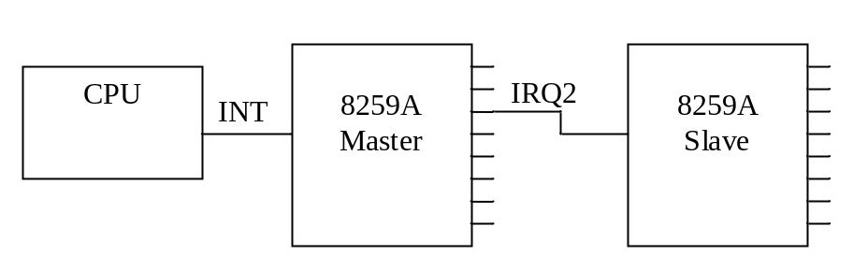
Figure 1 8259A cascaded master-slave configuration

Design goals and assumptions
- Perform the absolute minimum of processing for an interrupt
Since the execution of an interrupt handler is not under control of the scheduler, processing should return to the scheduler as soon as possible to reduce the period of non-determinism.
- Avoid reentrant interrupts
Each interrupt handler requires stack space, so the current handler should finish and clean up before the next one starts, to avoid overflow
- Minimize the time (#instructions) that interrupts are disabled
With interrupts disabled the CPU will not respond to external interrupts, which directly affects real-time characteristics (interrupt latency: time between the occurrence of an interrupt and the execution of the first instruction of the corresponding handler).

Context
The interrupt handling subsystem (IHS) must obviously interface with the hardware to setup and control the processing of interrupts. In addition, to limit the amount of unscheduled asynchronous execution, the IHS typically hands off the bulk of the work to a waiting thread, which requires and interface with the thread scheduler. The scheduler in turn must sometimes coordinate exclusive execution of critical sections, which may require the selective disabling of particular interrupts.
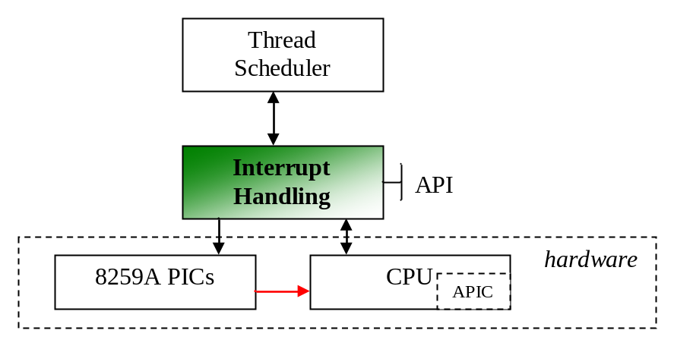
Figure 2 IHS interfaces

Component | Provided by IHS | Used by IHS
Thread Scheduler | - Prevent (mask) interrupt(s) | - wake up thread
8259A PIC |  | - Initialization  - Signal EOI
CPU | - Interrupt handler points | - Enable interrupts  - Disable interrupts  - Initialize IDT
APIC (optional) |  | - Initialization  - Set softIRQ level

The Interrupt Descriptor Table (IDT)
In protected mode interrupt handlers are put in a table called the Interrupt Descriptor Table (IDT). Of relevance for the IHS is that through the IDT the CPU may be configured to automatically disable interrupts before executing the handler. This is the difference between an “interrupt gate” (INTs disabled in EFLAGS) and a “trap gate” (EFLAGS unmodified, so either enabled or disabled). Having interrupts enabled means that higher priority IRQs may interrupt the current handler at any time.

The 8259A PIC
The 8259A is an ancient relic from the time of the 8086. Nevertheless, it is still used (or rather emulated) in modern systems. The 8259A can operate in several modes and has lots of functionality, although not everything is relevant for the i386 architecture.

Normal operation for an 8259A looks something like this:
- A device signals an interrupt
- The 8259A records the interrupt in the in-service register and handshakes with the CPU
- CPU acknowledges the interrupt, and receives the vector (offset into IDT) to invoke. All interrupts of equal or lower priority are inhibited until EOI
- Handler is called, saves all registers and other CPU state that it will modify
- Handler issues ‘EOI’ to the 8259A, which clears the in-service bit.
- Handler restores CPU state
- Handler issues ‘iret’ which returns the CPU to what it was doing before

“Specific” versus “non-specific” End-of-interrupt
The 8259A must be told when the interrupt handler is finished. If automatic EOI is not used (see 4.2.2) there are two possibilities: a specific or a non-specific EOI command. The difference is that for a non-specific EOI the 8259A chip will determine which line is being ACKed. Linux uses specific EOI which is always possible; non-specific EOI is only possible when:
- The 8259A operates in so-called “nested mode” and
- Not ( The interrupt is masked and special masked mode is used )

My interpretation: non-specific works unless priorities are changed or rotated, in which case the 8259A can no longer determine which bit to reset. To stay on the safe side, it is probably better to use either a specific EOI or automatic mode (see next section)

Automatic End-Of-Interrupt (AEOI)
When automatic EOI is enabled, the 8259A chip will automatically assume a non-specific EOI command after the INTA cycle with the CPU. According to the specs this should “only be used when a nested multilevel interrupt structure is not required within a single 8259A”. In addition, older 8259As (before 1985) only support AEOI on the master chip.
This design choice is complicated to make, since it is difficult to interpret the exact meaning of the specs, newer PIC chips may emulate it differently. AEOI mode may potentially save one (master) or two (master + slave) ‘out’ commands to IO ports, but at the same time one looses the automatic prevention of nested interrupts on the same line.
When looking at the datasheets of more modern PICs (e.g. Intel 82371AB PIIX4 Southbridge) the recommendation is to set AEOI to 0.

Special Mask Mode
During regular operation lower or equal priority interrupts are inhibited until the current ISR sends an EOI command to the PIC. Using so-called “Special Mask Mode” the ISR can re-enable lower priority interrupts, while still inhibiting interrupts of the same level.

Slave interrupts
Interrupts passing through the slave PIC (IRQ8 through IRQ15) are routed to IRQ2 of the master, and hence receive third priority (after IRQ0(timer) and IRQ1(keyboard)). This cascaded setup means that the handler must execute some additional steps, such as sending an EOI to both the master and the slave. It also means that while one of the slave interrupts is being serviced, all others are inhibited since the master’s IRQ2 line is blocked until EOI is received. To address this situation the 8259A may operate in “Special Fully Nested mode” in which higher priority slave interrupts (e.g. IRQ9 is being handled and then IRQ8 occurs) are admitted. It does imply that the handler must check if there are any remaining interrupts in service for the slave, by reading the ISR register after it sends ‘EOI’.
It remains to be tested if the same can be achieved by sending an early EOI to the master, either explicitly or using auto EOI mode.

How Linux does it
The Linux kernel is often a good source for examples on how to do things, so let’s take a look (kernel version 2.5.70). See http://tamacom.com/tour/kernel/linux/S/62.html#385 on how IRQ stubs are built up. The code that is executed basically comes down to:
Pushl IRQ_number
Jmp common_routine
…
common_routine:
save_all_registers()
set_DS_to_userseg()
do_IRQ()
jmp ret_from_intr
…
ret_from_intr:
GET_THREAD_INFO(%ebp)
movl EFLAGS(%esp), %eax # mix EFLAGS and CS
movb CS(%esp), %al
testl $(VM_MASK | 3), %eax
jz restore_all # returning to kernel or vm86-space
…
restore_all:
restore_all_registers()
addl $4, %esp
iret

As can be see from the above code, there are several jumps which from a performance perspective could be optimized. In addition, the real handling of the IRQ is in do_IRQ() (C code) see http://tamacom.com/tour/kernel/linux/S/49.html#345:
- maintain some statistics (enter_irq)
- obtain spinlock for the handler
- call ‘ack’ handler ( disable_8259A_irq at http://tamacom.com/tour/kernel/linux/S/89.html#90 or mask_and_ack_8259A at http://tamacom.com/tour/kernel/linux/S/89.html#171, depending on whether auto-EOI is used
- handle events in a loop, allowing for new IRQs that happen during handling; each ‘handle_IRQ_event’ may call a chain of handlers (to support shared interrupts); after handling local interrupts are *disabled* (cli). Handlers may specify a flag to prevent enabling interrupts (sti) before handling, so likely interrupts are generally *disabled* upon entry to handle_IRQ_event but enabled before calling the handler
- call ‘end’ handler (end_8259A_irq at http://tamacom.com/tour/kernel/linux/S/89.html#42 which in turn calls enable_8259A_irq)
- exit_irq which may handle softIRQs if any

The latest kernel (2.6.10) contains some optimization code that avoids locking for per-CPU interrupts (e.g. inter-processor interrupts) but the code mostly looks the same. There are patches available (see e.g. [4]) that improve interrupt latency.

Of interest is also the code in i8259.c which comments “Careful! The 8259A is a fragile beast, it pretty much _has_ to be done exactly like this (mask it first, _then_ send the EOI, and the order of EOI to the two 8259s is important!”
The code masks the occurring IRQ before sending a specific EOI, first the slave and then the master. In my own OS I have been using auto-EOI for the master (for the slave it did not work for some reason) and it seemed to work also without masking the IRQ first (although I must admit this was not tested intensively or on multiple systems).

Concluding, I would say that the Linux code is very generic and (therefore) likely to work on many machines but (as a result) not very optimized. Interrupt handling is mixed with SMP code (which is not disabled for uni-processor kernels), softirqs (apparently a replacement for bottom half handlers from v2.2) and code to handle signals (a Unix software interrupt concept). All in all very complex.

Some of the complexity may come from the legacy of i386 hardware, see [3] for an overview of the Linux interrupt architecture with the Sega dreamcast as target platform (which reportedly has a simpler PIC).

Additional mechanisms
As described in [1] section 4, CPUs with a local APIC (most Intel Pentiums and AMD Athlons(K7) and above) may benefit from a ‘software IRQ’ mechanism to call the thread scheduler at the appropriate moment (i.e. when no more interrupts require service). Without local APIC support this would have to be implemented by increasing a counter upon handler entry, decreasing it upon exit, and jump-if-zero to code that checks if any new threads were woken.

References
- Advanced programmable interrupt controller, http://osdev.berlios.de/pic.html (visited 15/1/05)
- Linux source code for handling 8259A, http://tamacom.com/tour/kernel/linux/S/89.html#171
- “The Linux interrupt controller API”, http://www.di.unipi.it/~scordino/linux_interrupts.pdf
- The Linux "real time interrupt patch", http://linuxdevices.com/articles/AT6105045931.html

